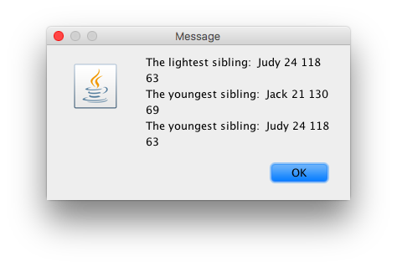

public class Sibling {

//3 instace private varibales

private String name;

private int age;

private int weight;

//create a constrcutor for intitalizing it. (can be done through ecipse source

public Sibling(String name, int age, int weight) {

super();

this.name = name;

this.age = age;

this.weight = weight;

}

//constructor public class_name (data type, data type w)

//constructor this. variable // . means

// click on the varibale and source to generate consturcotr or methods.

//generated methods.

public String getName() {

return name;

}

public int getAge() {

return age;

}

public int getWeight() {

return weight;

}

}

public class SiblingExt extends Sibling{ //extends the class sibling

//blueprint of the previous class.

private int height;

public SiblingExt (String name, int age, int weight, int height )

{

super (name,age,weight ); //firs tinstrcution in the method, siblext will class sibl construntor.

//calls the object constructor. *chain of construcotrs

this.height = height;

}

//create a siblext object.

//call the method

public int getHeight ( )

{

return height;

}

}

import javax.swing.JOptionPane;

public class TestSiblingExt {

public static void main (String args[]){

String in, out;

String name;

int id, age, weight, height;

name =JOptionPane.showInputDialog("Enter name");

in = JOptionPane.showInputDialog("Enter age");

age = Integer.parseInt(in);

in = JOptionPane.showInputDialog("Enter weight");

weight = Integer.parseInt(in);

in = JOptionPane.showInputDialog("Enter height");

height = Integer.parseInt(in);

//create the first sibling object

//class object = new Extended_Class constructor

SiblingExt sibe1 = new SiblingExt(name,age,weight,height);

//create another sib

name =JOptionPane.showInputDialog("Enter name");

in = JOptionPane.showInputDialog("Enter age");

age = Integer.parseInt(in);

in = JOptionPane.showInputDialog("Enter weight");

weight = Integer.parseInt(in);

in = JOptionPane.showInputDialog("Enter height");

height = Integer.parseInt(in);

//create the first sibling object

//class object = new Extended_Class constructor

SiblingExt sibe2 = new SiblingExt(name,age,weight,height);

//creather 3ed sib

name =JOptionPane.showInputDialog("Enter name");

in = JOptionPane.showInputDialog("Enter age");

age = Integer.parseInt(in);

in = JOptionPane.showInputDialog("Enter weight");

weight = Integer.parseInt(in);

in = JOptionPane.showInputDialog("Enter height");

height = Integer.parseInt(in);

//create the first sibling object

//class object = new Extended_Class constructor

SiblingExt sibe3 = new SiblingExt(name,age,weight,height);

//find the lgihtest. can use if loop. compairson

SiblingExt lightest = null;

if (sibe1.getWeight() <= sibe2.getWeight() &&

sibe1.getWeight() <= sibe3.getWeight() )

{

lightest = sibe1;

}

else if (sibe2.getWeight() <= sibe1.getWeight() &&

sibe2.getWeight() <= sibe3.getWeight() )

{

lightest = sibe2;

}

else

{

lightest = sibe3;

}

//create a reference variable for the youngest

SiblingExt youngest = null;

//youngest

if (sibe1.getAge() <= sibe2.getAge() &&

sibe1.getAge() <= sibe3.getAge() )

{

youngest = sibe1;

}

else if (sibe2.getAge() <= sibe1.getAge() &&

sibe2.getAge() <= sibe3.getAge())

{

youngest = sibe2;

}

else

{

youngest = sibe3;

}

//tallest

SiblingExt tallest;

if (sibe1.getHeight() <= sibe2.getHeight() &&

sibe1.getHeight() <= sibe3.getHeight() )

{

tallest = sibe1;

}

else if (sibe2.getHeight() <= sibe1.getHeight() &&

sibe2.getHeight() <= sibe3.getHeight())

{

tallest = sibe2;

}

else

{

tallest = sibe3;

}

//output

out = "The lightest sibling: " +

lightest.getName() + " " +

lightest.getAge() + " " +

lightest.getWeight() + " \n" +

lightest.getHeight() + " \n" ;

out = out + "The youngest sibling: " +

youngest.getName() + " " +

youngest.getAge() + " " +

youngest.getWeight() + " \n" +

youngest.getHeight() + " \n";

out = out + "The youngest sibling: " +

tallest.getName() + " " +

tallest.getAge() + " " +

tallest.getWeight() + " \n" +

tallest.getHeight() + " \n";

//display output

JOptionPane.showMessageDialog(null, out);

}

}